MAFS.912.G-CO.3.10

Prove theorems about triangles; use theorems about triangles to solve problems.

Item Type
Hot Text – Drag and Drop

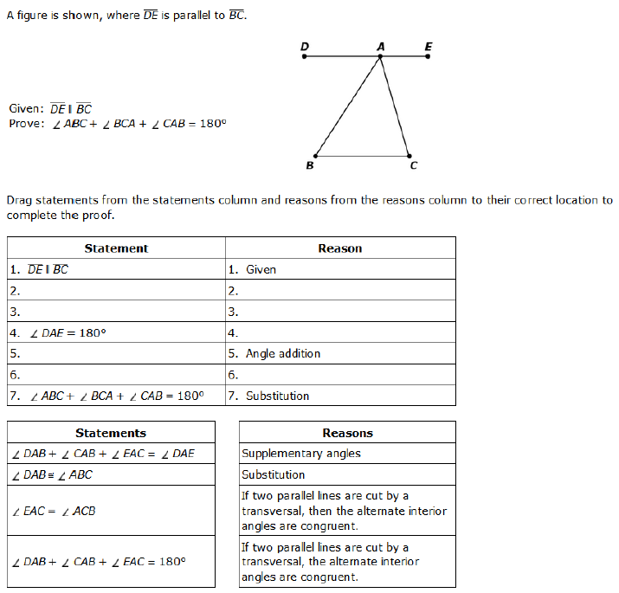
If 2 ǁines are cut by a transversal, alt int. <s =.
If 2 ǁines are cut by a transversal, alt int. <s =.

Substitution
Supplementary Angles
$$∠EAC=∠ACB$$

$$∠DAB+∠CAB+∠EAC=180°$$

$$∠DAB≅∠ABC$$
$$∠DAB+∠CAB+∠EAC=∠DAE$$

