MAFS.912.F-LE.2.5
Interpret the parameters in a linear or exponential function in terms of a context.

Item Type
Grid – Drag and Drop
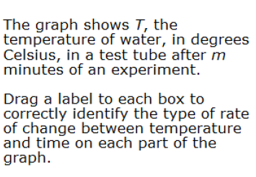
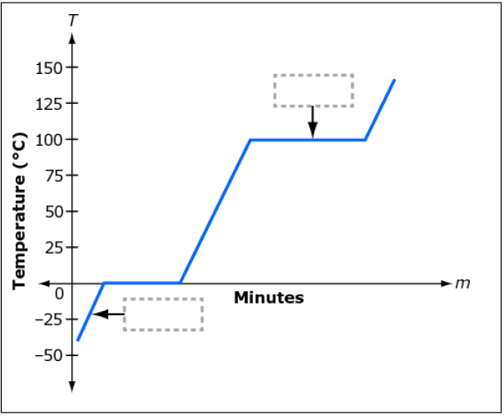
Teachers, in order for students to be able to practice this Technology-Enhanced Item (TEI) Type for the FSA, they should be able to simulate the action by clicking on the values given below in the rectangle and then dragging them to the correct boxes in order to complete the step and solution.
exponential
quadratic
constant
zero

