MAFS.912.F-LE.1.1
Distinguish between situations that can be modeled with linear functions and with exponential functions.
a. Prove that linear functions grow by equal differences over equal intervals and that exponential functions grow by equal factors over equal intervals.
b. Recognize situations in which one quantity changes at a constant rate per unit interval relative to another.
c. Recognize situations in which a quantity grows or decays by a constant percent rate per unit interval relative to another.

Item Type
Grid – Drag and Drop
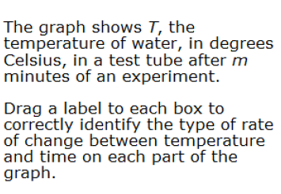
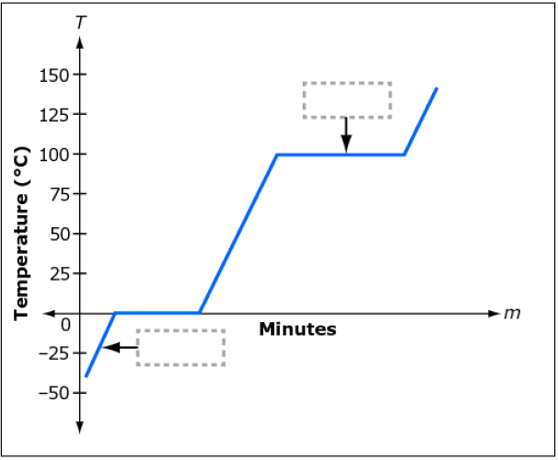
Teachers, in order for students to be able to practice this Technology-Enhanced Item (TEI) Type for the FSA, they should be able to simulate the action by clicking on the values given below in the rectangle and then dragging them to the correct boxes in order to complete the step and solution.
exponential
quadratic
constant
zero

