**MAFS.912.F-IF.3.9**

Compare properties of two functions each represented in a different way (algebraically, graphically, numerically in tables, or by verbal descriptions). For example, given a graph of one quadratic function and an algebraic expression for another, say which has the larger maximum.

**Item Type**

**Grid – Drag and Drop**

*Teachers, in order for students to be able to practice this Technology-Enhanced Item (TEI) Type for the FSA, they should be able to simulate the action by clicking on the values given below in the rectangle and then dragging them to the correct boxes in order to complete the step and solution.*

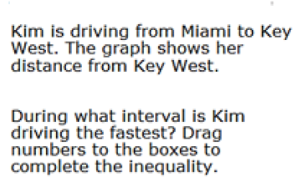

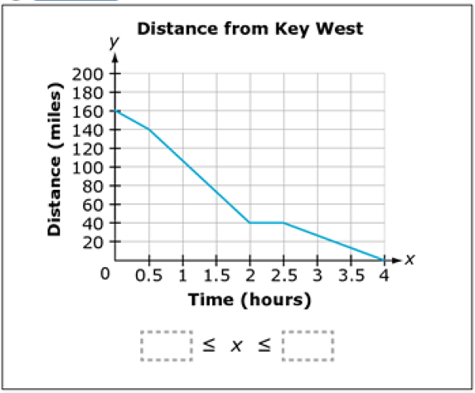

**0**

**0.5**

**1**

**1.5**

**2**

**2.5**

**3**

**3.5**

**4**