**MAFS.912.F-IF.3.8**

Write a function defined by an expression in different but equivalent forms to reveal and explain different properties of the function.

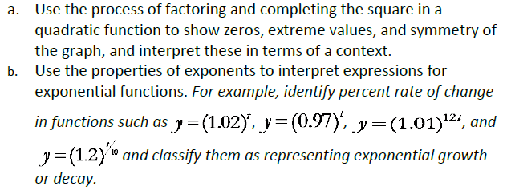

**Item Type**

**Equation Editor and Multi-Select**

*Teachers, in order for students to be able to practice this Technology-Enhanced Item (TEI) Type for the FSA, they should access the given hyperlink. The” Equation Editor” tutorial on the FSA portal can be used to solve this sample item. After the initial link to the portal, students would need to click the* ***green*** *Next* ***arrow****.*

[*http://demo.tds.airast.org/eqtutorial/?c=florida_pt&language=true#*](http://demo.tds.airast.org/eqtutorial/?c=florida_pt&language=true)

***Students would then need to select two options from the drop down menus.***

***NOTE: Based on the given information in the item, the teacher would need to direct students as to which selection to make in the Question drop down menu because the Editor may be slightly different for each.***

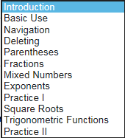 *Grade: (6-12) and Question:*

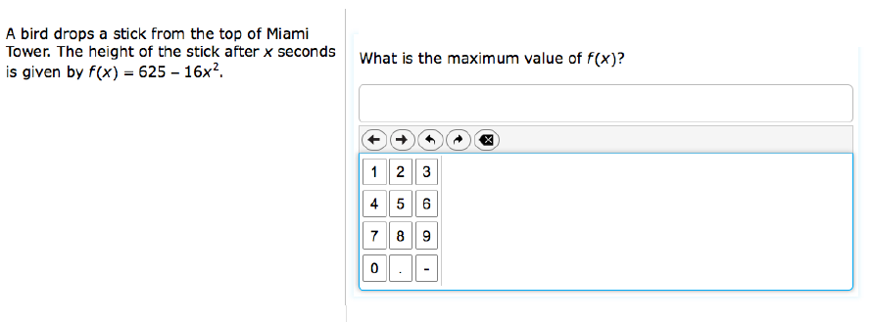

*Teachers, in order for students to be able to practice the Multi-Select Technology-Enhanced Item (TEI) Type for the FSA, students would drag the check marks (below the problem) to the boxes that are given in order for them to show their answer choices.*

***Keep in mind that all correct answers must be selected for a student to receive any credit for the item.*

