MAFS.912.F-IF.2.4
For a function that models a relationship between two quantities, interpret key features of graphs and tables in terms of the quantities and sketch graphs showing key features given a verbal description of the relationship. Key features include: intercepts; intervals where the function is increasing, decreasing, positive, or negative; relative maximums and minimums; symmetries; end behavior; and periodicity.

Item Type
Grid – Drag and Drop
Teachers, in order for students to be able to practice this Technology-Enhanced Item (TEI) Type for the FSA, they should be able to simulate the action by clicking on the values given below in the rectangle and then dragging them to the correct boxes in order to complete the step and solution.

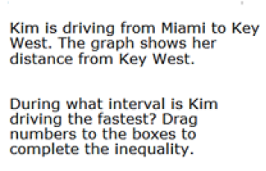
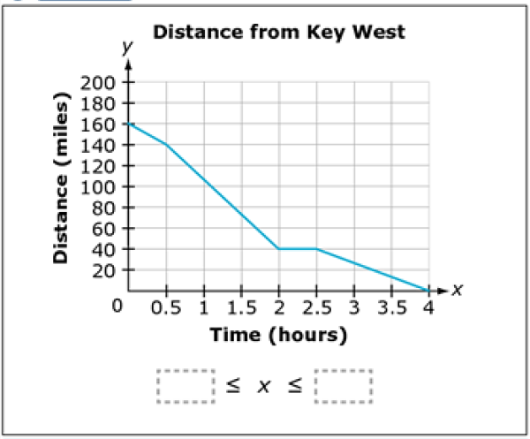
0
0.5

1
1.5
2
2.5
3

3.5
4

