**MAFS.912.F-BF.2.4**

Find inverse functions.

a. Solve an equation of the form f(x) = c for a simple function, f, that has an inverse and write an expression for the inverse. For example, f(x) =2x³ or f(x) = (x+1)/(x–1) for x ≠ 1.

b. Verify by composition that one function is the inverse of another.

c. Read values of an inverse function from a graph or a table, given that the function has an inverse.

d. Produce an invertible function from a non-invertible function by restricting the domain.

**Item Type**

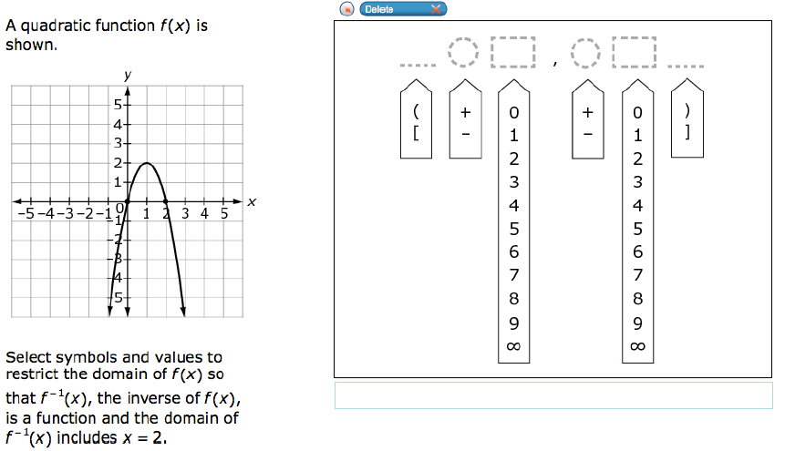**GRID: Hot Spot**

)

7

0

+

7

0

+

(

]

8

1

-

8

1

-

[

6

∞

9

5

4

3

2

∞

9

6

5

4

3

2