|  |
| --- |
| **MAFS.912.A-REI.2.4** |
| Solve quadratic equations in one variable.  a. Use the method of completing the square to transform any quadratic equation in *x* into an equation of the form (*x* – *p*)² = *q* that has the same solutions. Derive the quadratic formula from this form.  b. Solve quadratic equations by inspection (e.g., for *x*² = 49), taking square roots, completing the square, the quadratic formula, and factoring, as appropriate to the initial form of the equation. Recognize when the quadratic formula gives complex solutions and write them as *a* ± *bi* for real numbers *a* and *b* |

**Item Type**

**Grid: Drag and Drop**

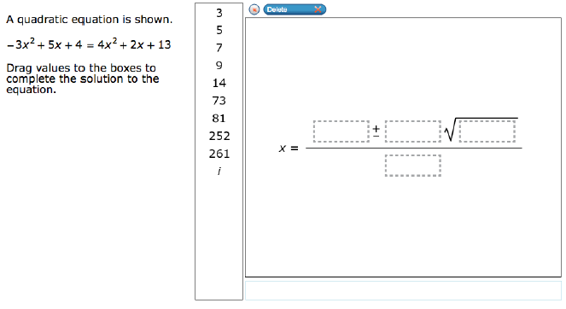

9*i*

3

*i*

261

252

81

73

14

9

7

5

3