MAFS.912.A-REI.2.3 | Solve linear equations and inequalities in one variable, including equations with coefficients represented by letters.
Item Type
Grid – Drag and Drop
Teachers, in order for students to be able to practice this Technology-Enhanced Item (TEI) Type for the FSA, they should be able to simulate the action first by clicking on the yellow box and dragging it in order to “highlight” their answer choice in Part A.
For Part B, students would need to click on the answer choices given below and then drag them to the correct boxes in order to accurately complete the equation.
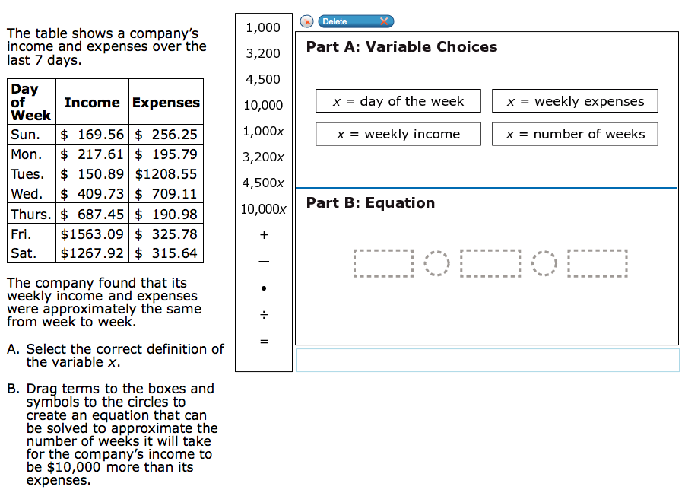

+
10,000x
4,500
+
$$-$$
$$÷$$
●
$$=$$
$$-$$
$$÷$$
$$=$$
●
4,500x
3,200x
1,000x
10,000
3,200
1,000

