MAFS.912.A-REI.1.2

Solve simple rational and radical equations in one variable, and give examples showing how extraneous solutions may arise.

Item Type
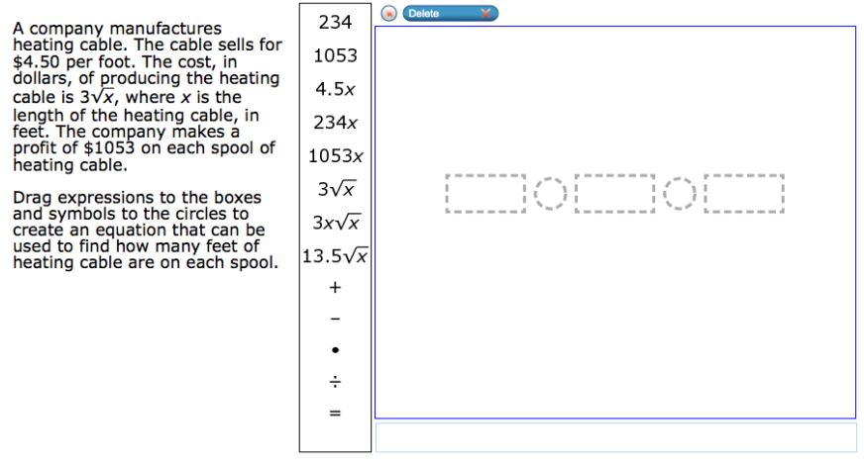
Grid – Drag and Drop
÷
+
-
$⦁$
=
13.5$\sqrt{x}$

3x$\sqrt{x}$

3$\sqrt{x}$
1053x
234x
4.5x
1053
234

