MAFS.912.A-REI.1.1 | Explain each step in solving a simple equation as following from the equality of numbers asserted at the previous step, starting from the assumption that the original equation has a solution. Construct a viable argument to justify a solution method.

Item Type
Hot Text and Drag and Drop
Teachers, in order for students to be able to practice this Technology-Enhanced Item (TEI) Type for the FSA, they should be able to simulate the “Hot Text Drag and Drop” action by clicking on their highlighted answer choice box and then dragging it to the correct place in the steps.

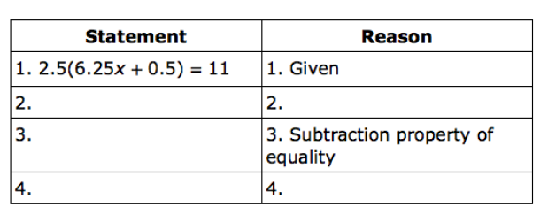

Symmetric property of equality
Division property of equality
Addition property of equality
Distributive property
Closure property

