**MAFS.912.A-CED.1.4**

Rearrange formulas to highlight a quantity of interest using the same reasoning as in solving equations.

**Item Type**

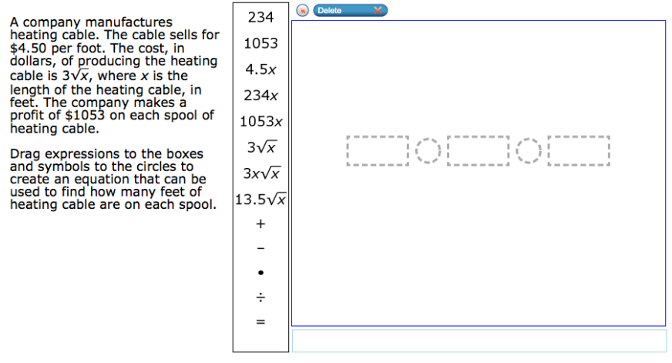**Grid – Drag and Drop**

÷

+

-

$⦁$

=

13.5 $\sqrt{x}$

3x $\sqrt{x}$

3 $\sqrt{x}$

1053x

234x

4.5x

1053

234