|  |  |
| --- | --- |
| **MAFS.912.A-CED.1.1** | **Create equations and inequalities in one variable and use them to solve problems.** *Include equations arising from linear and quadratic functions and simple rational, absolute, and exponential functions.* |

**Item Type**

**Grid – Drag and Drop**

*Teachers, in order for students to be able to practice this Technology-Enhanced Item (TEI) Type for the FSA, they should be able to simulate the action first by clicking on the yellow box and dragging it in order to “highlight” their answer choice in Part A.*

*For Part B, students would need to click on the answer choices given below and then drag them to the correct boxes in order to accurately complete the equation.*

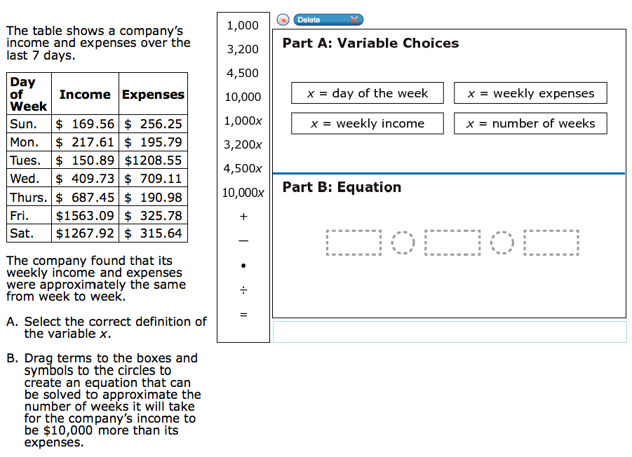

10,000x

4,500

4,500x

3,200x

1,000x

10,000

3,200

1,000