**MAFS.912.A-CED.1.1**

Create equations and inequalities in one variable and use them to solve problems. Include equations arising from linear and quadratic functions and simple rational, absolute, and exponential functions.

**Item Type**

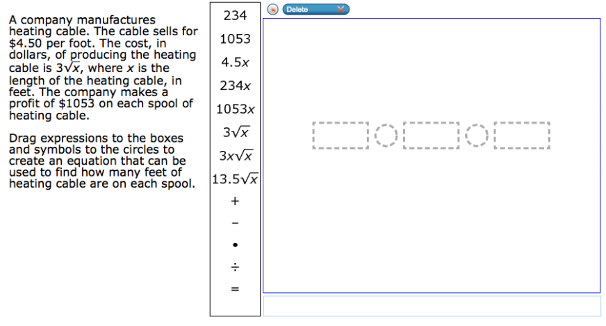**Grid – Drag and Drop**

÷

+

-

$⦁$

=

13.5 $\sqrt{x}$

3x $\sqrt{x}$

3 $\sqrt{x}$

1053x

234x

4.5x

1053

234