MAFS.912.A-APR.4.6
Rewrite simple rational expressions in different forms; write a(x)/b(x) in the form q(x) + r(x)/b(x), where a(x), b(x), q(x), and r(x) are polynomials with the degree of r(x) less than the degree of b(x), using inspection, long division, or, for the more complicated examples, a computer algebra system.
Item Type
Equation EditorTeachers, in order for students to be able to practice this Technology-Enhanced Item (TEI) Type for the FSA, have them access the given hyperlink. The” Equation Editor” tutorial on the FSA portal can be used to solve this sample item. After the initial link to the portal, students would need to click the green Next arrow.
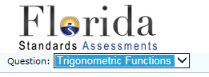
http://demo.tds.airast.org/eqtutorial/?c=florida_pt&language=true#
Choose “Trigonometric Functions” from the drop-down menu.

