MAFS.912.A-APR.2.2

Know and apply the Remainder Theorem: For a polynomial p(x) and a number a, the remainder on division by x – a is p(a), so p(a) = 0 if and only if (x – a) is a factor of p(x).

Item Type

Equation Editor
Teachers, in order for students to be able to practice this Technology-Enhanced Item (TEI) Type for the FSA, have them access the given hyperlink. The” Equation Editor” tutorial on the FSA portal can be used to solve this sample item. After the initial link to the portal, students would need to click the green Next arrow.

http://demo.tds.airast.org/eqtutorial/?c=florida_pt&language=true#

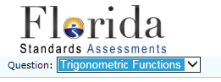
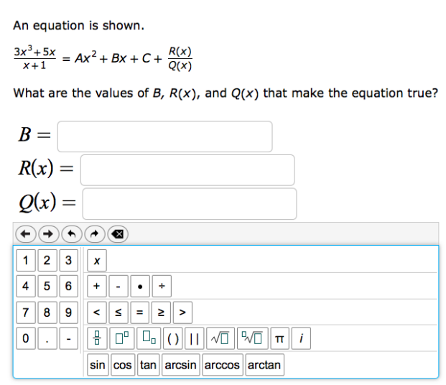
Choose “Trigonometric Functions” from the drop-down menu.

