MAFS.8.NS.1 Know that there are numbers that are not rational, and approximate them by rational numbers.
MAFS.8.NS.1.2 Use rational approximations of irrational numbers to compare the size of irrational numbers, locate them approximately on a number line diagram, and estimate the value of expressions (e.g., 𝜋2). For example, by truncating the decimal expansion of √2, show that √2 is between 1 and 2, then between 1.4 and 1.5, and explain how to continue on to get better approximations.

Item Type
Equation Editor

Teachers, in order for students to be able to practice this Technology-Enhanced Item (TEI) Type for the FSA, they should access the given hyperlink. The” Equation Editor” tutorial on the FSA portal can be used to solve this sample item. After the initial link to the portal, students would need to click the green Next arrow.
http://demo.tds.airast.org/eqtutorial/?c=florida_pt&language=true#
Students would then need to select two options from the drop down menus.
NOTE: Based on the given information in the item, the teacher would need to direct students as to which selection to make in the Question drop down menu because the Editor may be slightly different for each.
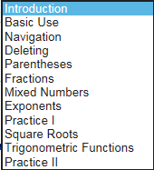
Grade: (6-12) and Question:

