MAFS.8.NS.1 Know that there are numbers that are not rational, and approximate them by rational numbers.
MAFS.8.NS.1.1 Know that numbers that are not rational are called irrational. Understand informally that every number has a decimal expansion; for rational numbers show that the decimal expansion repeats eventually, and convert a decimal expansion which repeats eventually into a rational number.

Item Type
Equation Editor

Teachers, in order for students to be able to practice this Technology-Enhanced Item (TEI) Type for the FSA, they should access the given hyperlink. The” Equation Editor” tutorial on the FSA portal can be used to solve this sample item. After the initial link to the portal, students would need to click the green Next arrow.
http://demo.tds.airast.org/eqtutorial/?c=florida_pt&language=true#
Students would then need to select two options from the drop down menus.
NOTE: Based on the given information in the item, the teacher would need to direct students as to which selection to make in the Question drop down menu because the Editor may be slightly different for each.
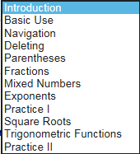
Grade: (6-12) and Question:

