MAFS.8.F.2 Use functions to model relationships between quantities.
MAFS.8.F.2.5 Describe qualitatively the functional relationship between two quantities by analyzing a graph (e.g., where the function is increasing or decreasing, linear or nonlinear). Sketch a graph that exhibits the qualitative features of a function that has been described verbally.
Item Type
Multi-Select
Teachers, in order for students to be able to practice the Multi-Select Technology-Enhanced Item (TEI) Type for the FSA, students would drag the check marks (below the problem) to the boxes that are given in order for them to show their answer choices.
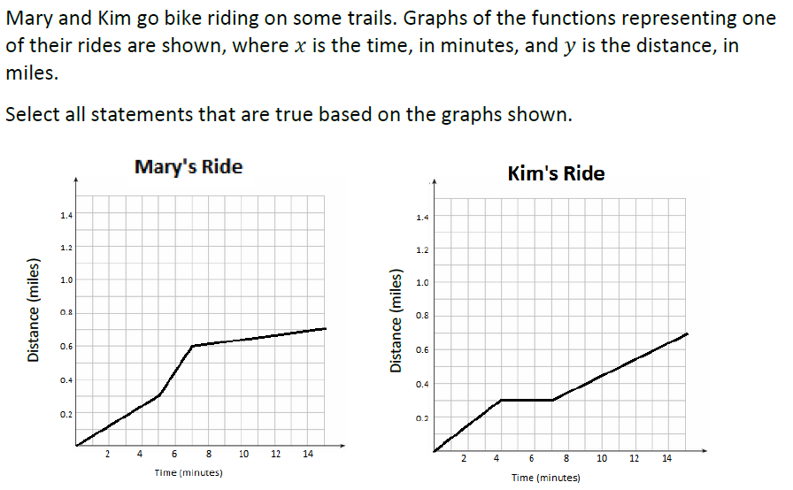
Keep in mind that all correct answers must be selected for a student to receive any credit for the item.

