***MAFS.8.F.1 Define, evaluate, and compare functions.***

**MAFS.8.F.1.2** Compare properties of two functions each represented in a different way (algebraically, graphically, numerically in tables, or by verbal descriptions). For example, given a linear function represented by a table of values and a linear function represented by an algebraic expression, determine which function has the greater rate of change.

**Item Type**

**Equation Editor**

*Teachers, in order for students to be able to practice this Technology-Enhanced Item (TEI) Type for the FSA, they should access the given hyperlink. The” Equation Editor” tutorial on the FSA portal can be used to solve this sample item. After the initial link to the portal, students would need to click the* ***green*** *Next* ***arrow****.*

[*http://demo.tds.airast.org/eqtutorial/?c=florida_pt&language=true#*](http://demo.tds.airast.org/eqtutorial/?c=florida_pt&language=true)

***Students would then need to select two options from the drop down menus.***

***NOTE: Based on the given information in the item, the teacher would need to direct students as to which selection to make in the Question drop down menu because the Editor may be slightly different for each.***

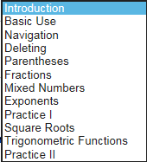 *Grade: (6-12) and Question:*

