***MAFS.8.EE.2 Understand the connections between proportional relationships, lines, and linear equations.***

**MAFS.8.EE.2.5** Graph proportional relationships, interpreting the unit rate as the slope of the graph. Compare two different proportional relationships represented in different ways. For example, compare a distance-time graph to a distance-time equation to determine which of two moving objects has greater speed.

**Item Type**

**Grid**

*Teachers, in order for students to be able to practice this Technology-Enhanced Item (TEI) Type for the FSA, they should be able to simulate the “Add Arrow Tool” in Part A by clicking on and then dragging the given arrow to the graph (extending/decreasing the length, if needed) to the correct location on the grid.*

**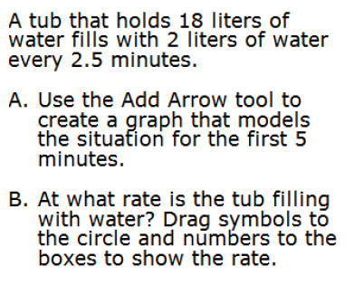***For Part B, use the symbols and numbers that are in the box to the right. Students should answer by clicking on and then dragging their solutions to the shapes in Part B.*



**1**

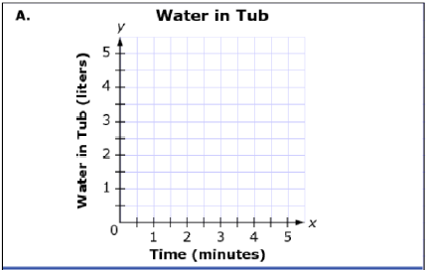

**2**

**3**

**4**

**5**

**6**

**7**

**8**

**9**

