***MAFS.8.EE.2 Understand the connections between proportional relationships, lines, and linear equations.***

**MAFS.8.EE.2.5** Graph proportional relationships, interpreting the unit rate as the slope of the graph. Compare two different proportional relationships represented in different ways. For example, compare a distance-time graph to a distance-time equation to determine which of two moving objects has greater speed.

**Item Type**

**Equation Editor**

*Teachers, in order for students to be able to practice this Technology-Enhanced Item (TEI) Type for the FSA, they should access the given hyperlink. The” Equation Editor” tutorial on the FSA portal can be used to solve this sample item. After the initial link to the portal, students would need to click the* ***green*** *Next* ***arrow****.*

[*http://demo.tds.airast.org/eqtutorial/?c=florida_pt&language=true#*](http://demo.tds.airast.org/eqtutorial/?c=florida_pt&language=true)

***Students would then need to select two options from the drop down menus.***

***NOTE: Based on the given information in the item, the teacher would need to direct students as to which selection to make in the Question drop down menu because the Editor may be slightly different for each.***

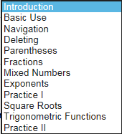 *Grade: (6-12) and Question:*

