MAFS.8.EE.1 Work with radicals and integer exponents.
MAFS.8.EE.1.2 Use square root and cube root symbols to represent solutions to equations of the form 𝑥2=𝑝 and 𝑥3=𝑝, where 𝑝 is a positive rational number. Evaluate square roots of small perfect squares and cube roots of small perfect cubes. Know that √2 is irrational.

Item Type
Equation Editor

Teachers, in order for students to be able to practice this Technology-Enhanced Item (TEI) Type for the FSA, they should access the given hyperlink. The” Equation Editor” tutorial on the FSA portal can be used to solve this sample item. After the initial link to the portal, students would need to click the green Next arrow.
http://demo.tds.airast.org/eqtutorial/?c=florida_pt&language=true#
Students would then need to select two options from the drop down menus.
NOTE: Based on the given information in the item, the teacher would need to direct students as to which selection to make in the Question drop down menu because the Editor may be slightly different for each.
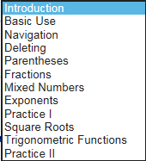
Grade: (6-12) and Question:

