MAFS.7.SP.1 Use random sampling to draw inferences about a population.
MAFS.7.SP.1.2 Use data from a random sample to draw inferences about a population with an unknown characteristic of interest. Generate multiple samples (or simulated samples) of the same size to gauge the variation in estimates or predictions. For example, estimate the mean word length in a book by randomly sampling words from the book; predict the winner of a school election based on randomly sampled survey data. Gauge how far off the estimate or prediction might be.

Item Type
Equation Editor

Teachers, in order for students to be able to practice this Technology-Enhanced Item (TEI) Type for the FSA, they should access the given hyperlink. The” Equation Editor” tutorial on the FSA portal can be used to solve this sample item. After the initial link to the portal, students would need to click the green Next arrow.
http://demo.tds.airast.org/eqtutorial/?c=florida_pt&language=true#
Students would then need to select two options from the drop down menus.
NOTE: Based on the given information in the item, the teacher would need to direct students as to which selection to make in the Question drop down menu because the Editor may be slightly different for each.
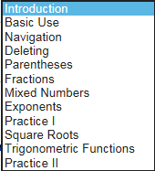
Grade: (6-12) and Question:

