MAFS.7.SP.1 Use random sampling to draw inferences about a population.

MAFS.7.SP.1.1 Understand that statistics can be used to gain information about a population by examining a sample of the population; generalizations about a population from a sample are valid only if the sample is representative of that population. Understand that random sampling tends to produce representative samples and support valid inferences.

Item Type
Equation Editor

Teachers, in order for students to be able to practice this Technology-Enhanced Item (TEI) Type for the FSA, they should access the given hyperlink. The” Equation Editor” tutorial on the FSA portal can be used to solve this sample item. After the initial link to the portal, students would need to click the green Next arrow.
http://demo.tds.airast.org/eqtutorial/?c=florida_pt&language=true#
Students would then need to select two options from the drop down menus.
NOTE: Based on the given information in the item, the teacher would need to direct students as to which selection to make in the Question drop down menu because the Editor may be slightly different for each.
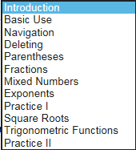
Grade: (6-12) and Question:

