MAFS.6.NS.3 Apply and extend previous understandings of numbers to the system of rational numbers.
MAFS.6.NS.3.6a Recognize opposite signs of numbers as indicating locations on opposite sides of 0 on the number line; recognize that the opposite of the opposite of a number is the number itself, e.g., −(−3) = 3, and that 0 is its own opposite.
MAFS.6.NS.3.6b Understand signs of numbers in ordered pairs as indicating locations in quadrants of the coordinate plane; recognize that when two ordered pairs differ only by signs, the locations of the points are related by reflections across one or both axes.
MAFS.6.NS.3.6c Find and position integers and other rational numbers on a horizontal or vertical number line diagram; find and position pairs of integers and other rational numbers on a coordinate plane.
Teachers, in order for students to be able to practice this Technology-Enhanced Item (TEI) Type for the FSA, they should be able to simulate the “Add Point Tool” by dragging the given point(s) to their correct location(s) on the grid.
Item Type
Grid

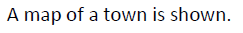
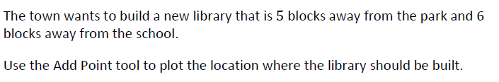

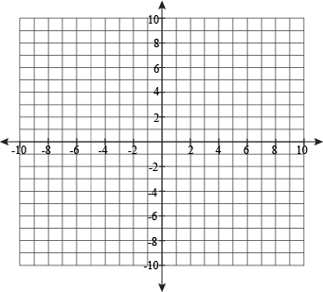
Drag the given point below (by clicking on the group) to the location on the grid in order to identify where the library should be built.

SCHOOL

BANK

LIBRARY
PARK

